CSCD350 Assignment 7

Team: Fast Fire File Flyers(4F) Lead: Brandon Fowler

Members: James White, Zach Lontz, Daniil Borisov, Brandon Fowler

Create pivotal tracker project called TriviaMaze_4F_CSCD350 and four stories for the first project iteration:

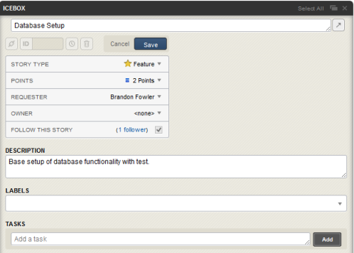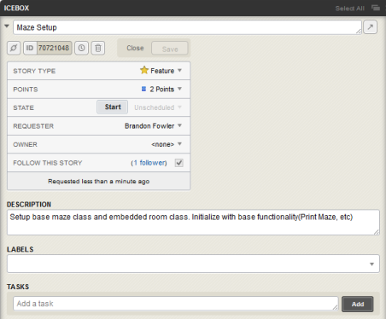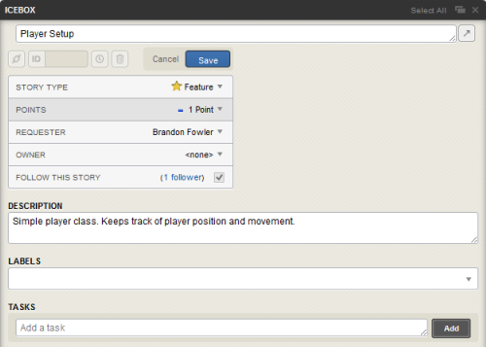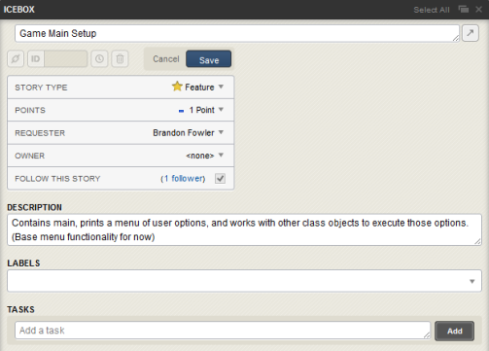

All four stories are added to the current iteration, and are accepted by team members:

